User: Create POST method to add employee

GitHub Copilot: Optimized tool selectionI'll help you create a POST method to add an employee. Let me first examine the existing code structure.

Read [](file:///c%3A/Personal/Fint%20Solution/Day%202/ASP%20Web%20API/EmployeeContextDemo/EmployeeContextDemo/Models/Employee.cs)

Read [](file:///c%3A/Personal/Fint%20Solution/Day%202/ASP%20Web%20API/EmployeeContextDemo/EmployeeContextDemo/Services/IEmployeeService.cs)

Read [](file:///c%3A/Personal/Fint%20Solution/Day%202/ASP%20Web%20API/EmployeeContextDemo/EmployeeContextDemo/Controllers/EmployeesController.cs)

Read [](file:///c%3A/Personal/Fint%20Solution/Day%202/ASP%20Web%20API/EmployeeContextDemo/EmployeeContextDemo/Services/EmployeeService.cs)

Now I'll add the POST method to the EmployeesController:

Replacing 14 lines with 27 lines in [](file:///c%3A/Personal/Fint%20Solution/Day%202/ASP%20Web%20API/EmployeeContextDemo/EmployeeContextDemo/Controllers/EmployeesController.cs)

```

```

Read [](file:///c%3A/Personal/Fint%20Solution/Day%202/ASP%20Web%20API/EmployeeContextDemo/EmployeeContextDemo/Controllers/EmployeesController.cs#1-1), lines 1 to 50

Done! I've added a POST method to the `EmployeesController`. The new `AddEmployee` method:

- Accepts Employee data in the request body
- Validates that the employee data is provided
- Calls `AddEmployeeAsync` from the service layer to add the employee
- Returns a `201 Created` response with the newly created employee and its location (via `CreatedAtAction`)

You can now test it by sending a POST request to `/api/employees` with a JSON payload:

```json
{
"name": "John Doe",
"department": "Finance",
"salary": 50000
}
```

The EmployeeId will be automatically generated based on the existing employees in the list.

Made changes.

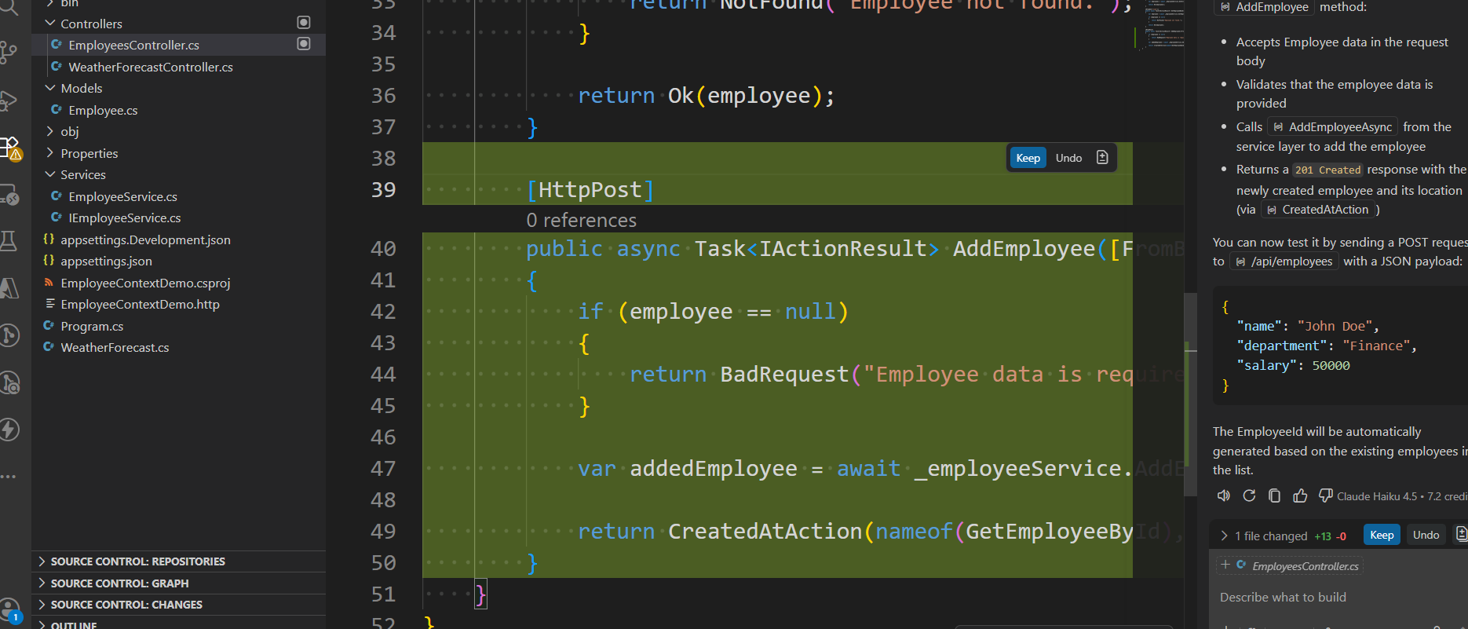

Prompt with @workspace

User: @workspace Analyze my EmployeeContextDemo project and create a POST method to add a new employee. Follow the existing controller-service-model pattern. Modify EmployeesController, IEmployeeService, and EmployeeService. Also tell me if Program.cs needs service registration changes.

GitHub Copilot: Read [](file:///c%3A/Personal/Fint%20Solution/Day%202/ASP%20Web%20API/EmployeeContextDemo/EmployeeContextDemo/Controllers/EmployeesController.cs)

Read [](file:///c%3A/Personal/Fint%20Solution/Day%202/ASP%20Web%20API/EmployeeContextDemo/EmployeeContextDemo/Services/IEmployeeService.cs)

Read [](file:///c%3A/Personal/Fint%20Solution/Day%202/ASP%20Web%20API/EmployeeContextDemo/EmployeeContextDemo/Services/EmployeeService.cs)

Read [](file:///c%3A/Personal/Fint%20Solution/Day%202/ASP%20Web%20API/EmployeeContextDemo/EmployeeContextDemo/Program.cs)

Perfect! I've analyzed your project. Here's what I found:

**Current State:**
- ✅ **IEmployeeService** already has `AddEmployeeAsync` method signature
- ✅ **EmployeeService** already has complete `AddEmployeeAsync` implementation (generates ID and adds employee)
- ✅ **Program.cs** already has service registration: `builder.Services.AddScoped<IEmployeeService, EmployeeService>();`
- ❌ **EmployeesController** is missing the POST method

**Good news:** No changes needed to Program.cs - your service registration is already in place!

Now I'll add the POST method to complete the pattern:

Replacing 14 lines with 27 lines in [](file:///c%3A/Personal/Fint%20Solution/Day%202/ASP%20Web%20API/EmployeeContextDemo/EmployeeContextDemo/Controllers/EmployeesController.cs)

```

```
Done! Here's what I've added:

**New POST Method in EmployeesController:**
- Accepts `Employee` data from request body
- Validates input (returns `400 BadRequest` if null)
- Calls the existing `AddEmployeeAsync` service method
- Returns `201 Created` status with the created employee and location header

**Summary:**
| Component | Status | Notes |
|-----------|--------|-------|
| EmployeesController | ✅ Modified | Added `[HttpPost] AddEmployee` method |
| IEmployeeService | ✅ Already set | `AddEmployeeAsync` already defined |
| EmployeeService | ✅ Already set | `AddEmployeeAsync` implementation ready |
| Program.cs | ✅ No changes needed | Service registration already configured |

**Test the endpoint:**
```
POST /api/employees
Content-Type: application/json

{
"name": "John Doe",
"department": "Finance",
"salary": 50000
}
```

The EmployeeId will be auto-generated based on the highest existing ID.

Made changes.
